**Task 2: Register an Azure Machine Learning Datastore**

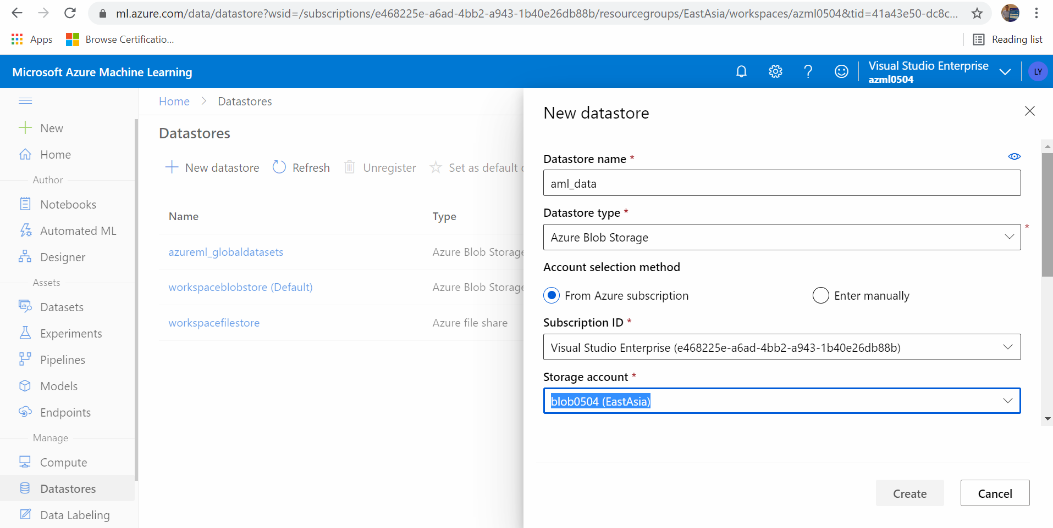

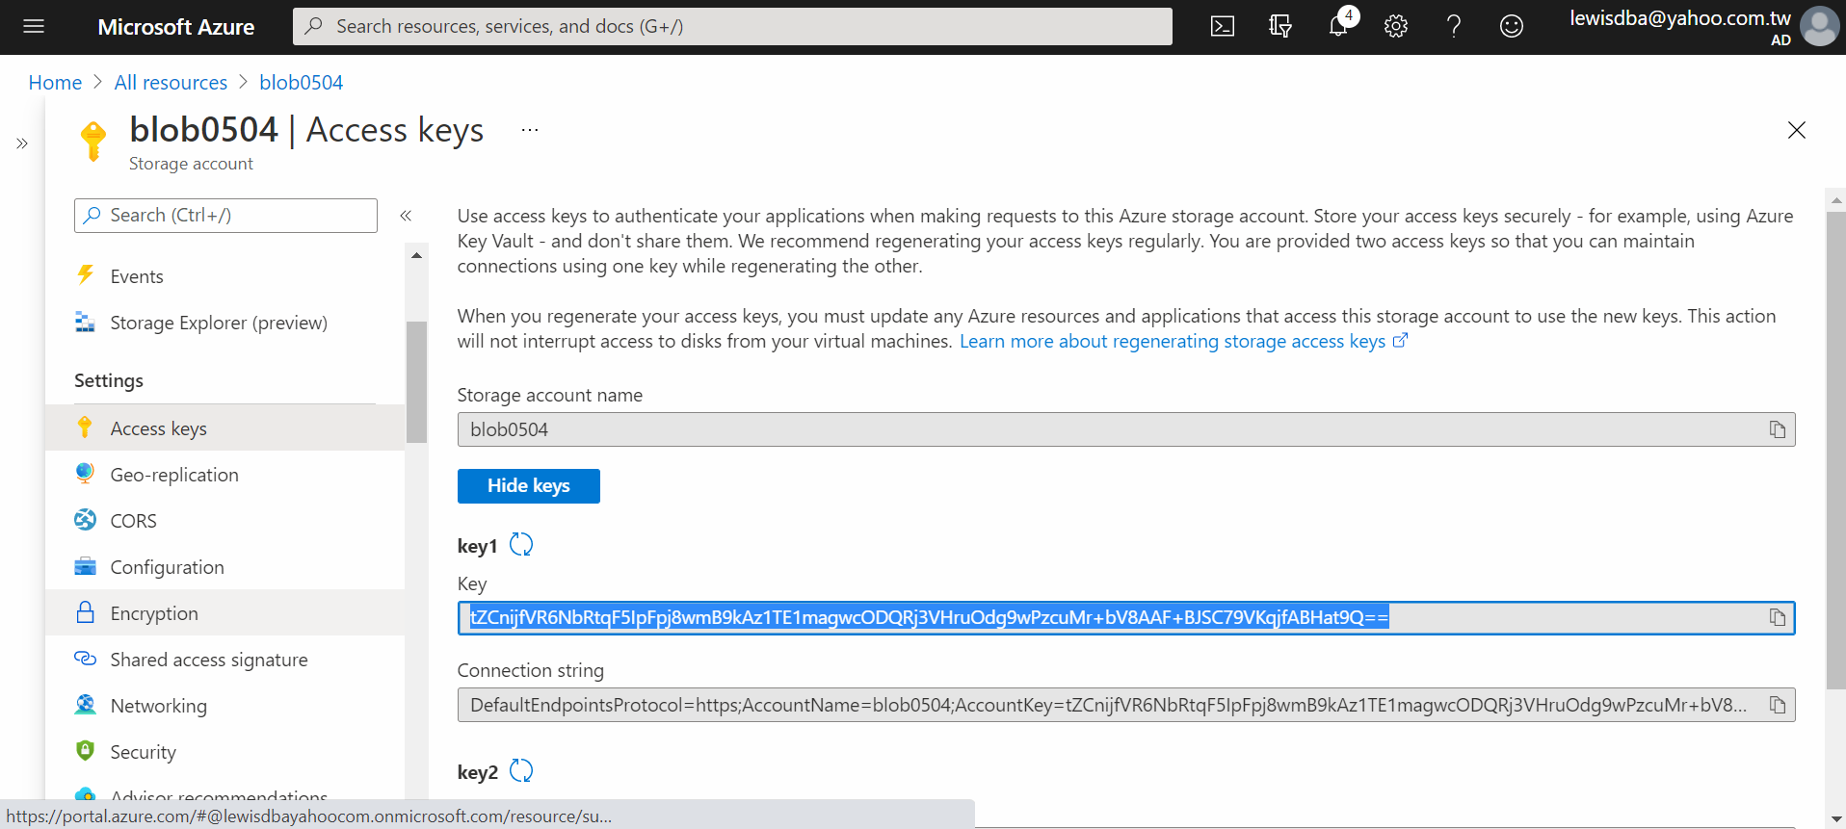

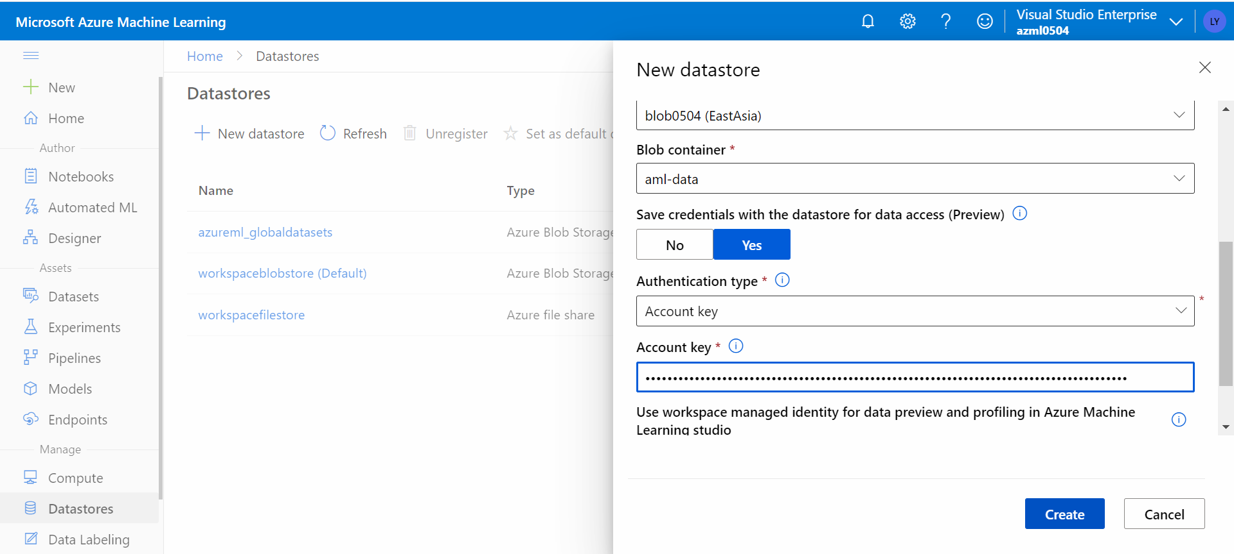

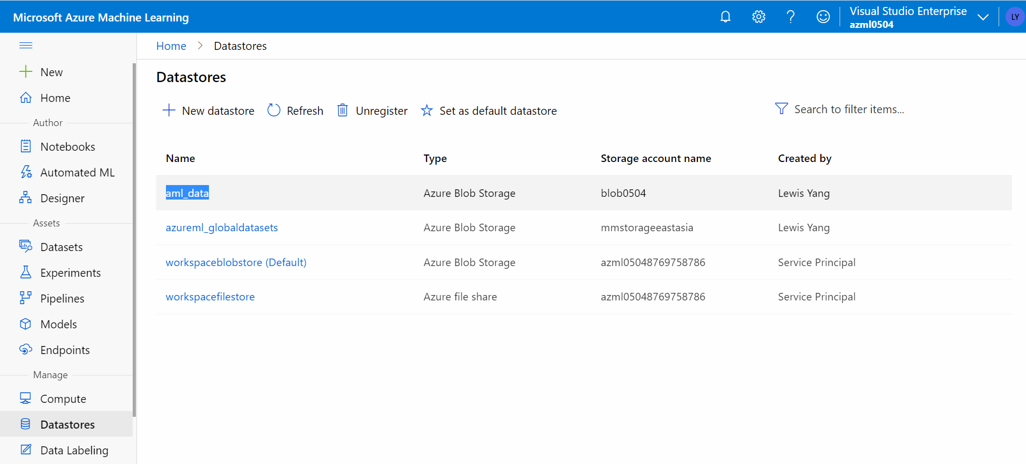

Azure Blob – Container 🡨 Account + Key 🡪 Azure Machine Learning – Workspace -- Datastores